Bio Anthony Calderon
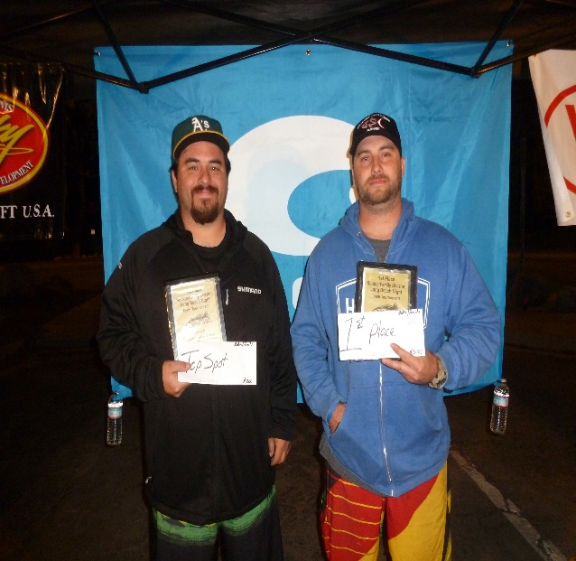I was born and raised in Southern California where I grew up fishing the local So Cal Ocean and lakes. When I Graduated High School I Joined the Air Force which allowed me to leave California and go to other states where I was able to pick up other techniques from the locals. When not fishing, I enjoy spending time with my kids Konnor and Kayleigh coaching their sports or teaching them to fish.
Over the years, I have competed in local tournaments and have had some success. In early 2018 I started my tournament career fishing with partner Dan Underwood in the Saltwater Bass Series. We took a First and a Second place along with two other top ten finishes. We made it to the end of year tournament where we were not able to make up from a slow day one we finished 20th overall.

Angling Stuff
Home Launch | Davies Launch Long Beach CA
Favorite Spot | Izors Reef
Favorite Bait | Hook Up Baits Red Crab
Favorite Technique | Drop Shot
Biggest Weakness | Spotted Bay Bass
Boat | Trophy
Motor | Mercury
Fishing Sponsors
Non-Fishing Sponsors
Tow Vehicle | 2018 Ford F-150
Personal Stuff
Favorite Food | Mexican
Favorite Music | Country
Favorite Book/Movie | Remember the Titans
Non-Angling Hero | Uncle, He taught me to love the outdoors especially fishing and hunting
When Not Fishing | Coaching Youth Sports Football and Baseball
Why He Fishes | "It's a combination of the competition and just being outdoors."

